**Project topic: ­- Multi indicator for stock market prediction using Machine Learning**

## **Group no: - 13**

## **Project**

|  |  |  |
| --- | --- | --- |
| Name | Roll no | Sign |
| Kartik Anil Thakre | IT20011 |  |
| Samiksha Dilip Wanjari | IT20025 |  |
| Rahul Mahesh Salame | IT20001 |  |
| Manish Ganesh Golhar | IT20020 |  |
| Rohit Ravindra Kashti | ITD20086 |  |

Project Supervisor

Name: - **Mr. Sachin Meshram**

Sign: -

**Project title**: - Multi indicator for stock market prediction using Machine Learning

**Abstract**: -

stock market represents a complex and dynamic financial environment, where investors seek profitable opportunities amidst constantly changing conditions. In this study, we present the development of a comprehensive multi-indicator system aimed at providing investors with valuable insights and informed decision-making capabilities in the stock market.

Our research begins with a comprehensive review of existing financial indicators, technical analysis tools, and fundamental metrics commonly utilized in stock market analysis. Through a systematic approach, we identify key strengths and limitations of individual indicators and discern opportunities for synergistic integration.

Next, we propose the creation of a novel multi-indicator that amalgamates a diverse range of complementary indicators, such as supertrend, relative strength index (RSI), Average directional index (ADX). Each indicator is carefully selected for its unique ability to capture distinct aspects of stock price movements, market trends, and underlying financial health.

The construction of this multi-indicator is underpinned by machine learning algorithms and statistical techniques. By leveraging historical stock market data and relevant financial information, we train the model to identify optimal indicator combinations and weightings to generate robust and timely buy/sell signals.

To evaluate the effectiveness of our multi-indicator system, we conduct extensive backtesting across various historical market scenarios. Additionally, we employ real-time simulations to assess the system's performance in dynamic market conditions. By comparing the results against traditional single-indicator strategies and buy-and-hold approaches, we demonstrate the potential advantages of our multi-indicator system.

Our findings reveal that the proposed multi-indicator system consistently outperforms individual indicators and delivers enhanced risk-adjusted returns. Moreover, the system exhibits resilience during market downturns and effectively minimizes the impact of false signals.

**Keyword:** - stock market, multi-indicator system, technical analysis, fundamental analysis, machine learning, financial indicators, market trends, decision-making.

**Proposed work: -**

* we propose the creation of a novel multi-indicator that will be the combination of three types of indicators which are Supertrend, Relative Strength Index (RSI), Average Directional Index (ADX).
* Each indicator is carefully selected for its unique ability to capture distinct aspects of stock price movements, market trends, and underlying financial health.
* The construction of this multi-indicator is underpinned by machine learning algorithms and statistical techniques. By leveraging historical stock market data and relevant financial information, we train the model to identify optimal indicator combinations and weightings to generate robust and timely buy/sell signals.

**Drawbacks of existing system: -**

* Using multiple indicators can make the analysis process more complex, especially for inexperienced traders. Different indicators may provide conflicting signals or lead to confusion when they generate mixed messages about the market's direction.
* Many commonly used indicators are based on past price movements, which means they are lagging indicators. By the time these indicators signal a trend change, the market may have already moved significantly in that direction, resulting in missed opportunities or delayed decision-making.
* Some indicators heavily rely on historical price data, which may not accurately represent the current market conditions or future trends. Market dynamics can change rapidly, and past performance does not always guarantee future outcomes.
* No indicator is perfect, and false signals can occur frequently, leading traders to make poor decisions. False signals can be especially problematic in volatile or choppy markets, where indicators may generate conflicting readings.
* Different traders may interpret the indicators differently, leading to varying trading decisions. This subjectivity can lead to inconsistency in trading strategies and outcomes.

**Architecture:-**

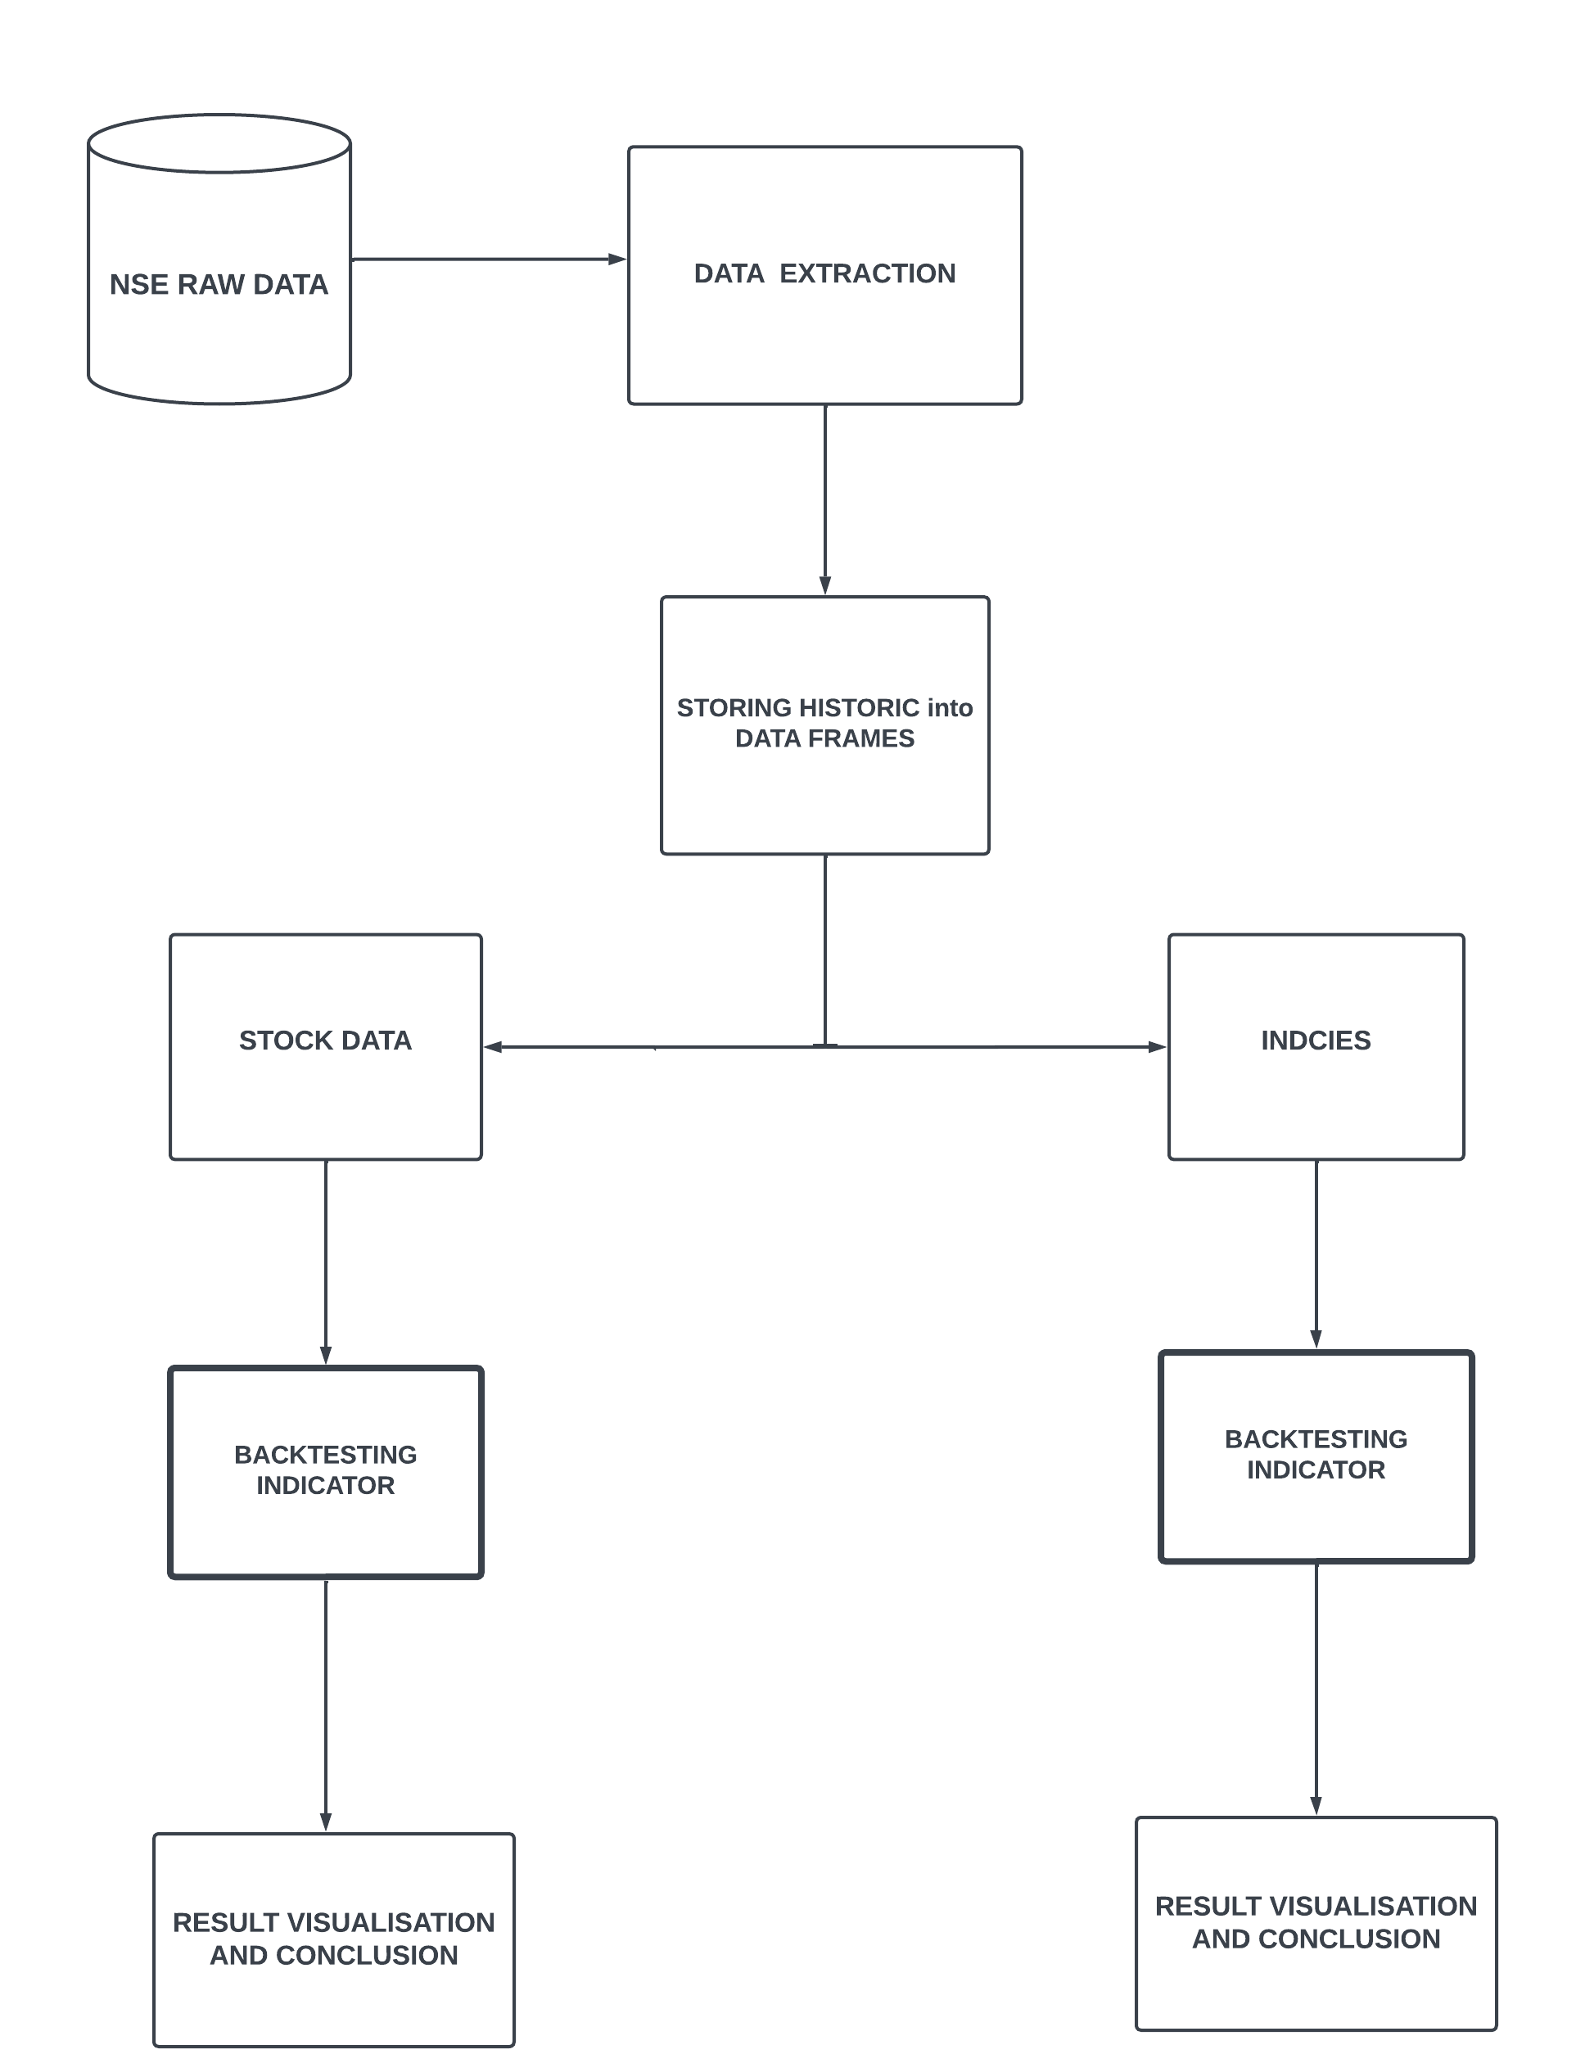

**Real time application:-**

* **Strength of a trend** :- An indicator can also help confirm the strength of a trend. In an uptrend, the Indicator tends to stay above 50, indicating positive momentum. In a downtrend, the indicator tends to stay below 50, indicating negative momentum. Traders can use this information to assess the strength of a trend before making trading decisions.
* **Beneficial**:- Using multi-indicators in stock market analysis can be beneficial as they provide a more comprehensive view of market trends and potential opportunities.
* **Spotting Divergence:-** Divergences between the price chart and the RSI can provide valuable insights.
* **Trend identification:-** Indicator can help identify the direction of the market's trend (upward, downward, or sideways). Traders may use this information to determine whether to take long (buy) or short (sell) positions.
* **Risk Management**: Indicators can aid in setting stop-loss levels and defining risk parameters for trades. This helps traders manage their risk and protect their capital.